**Eradication of Accidents Using Sensing Technology**

***A Mini Project Report Submitted to***

**JAWAHARLAL NEHRU TECHNOLOGICAL UNIVERSITY, HYDERABAD**

***In partial fulfillment of the award of Degree of Bachelor of Technology in***

***Computer Science and Engineering***

**Submitted**

**By**

**G.Vikas Kiran 13881A05P1**

**Under the Supervisionof**

**Mr. S.Venu Gopal**

**Assistant Professor**

**Department of CSE**

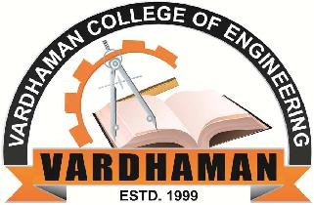

**Computer Science and Engineering**

|  |
| --- |
| **VARDHAMAN COLLEGE OF ENGINEERING**  **(AUTONOMOUS)** |
| **Shamshabad-501218, Hyderabad.** |

**August, 2016**